- We are developing an online T-shirt sales system. The total order cost is calculated based on the following two factors:
Product category:
Basic T-shirt
Printed T-shirt
Premium T-shirt
Order quantity:
Small (1–50 T-shirts)
Medium (51–100 T-shirts)
Large (101 or more T-shirts)
Cost calculation rules:
Base price (per T-shirt)
Basic T-shirt: 20 RMB
Printed T-shirt: 45 RMB
Premium T-shirt: 120 RMB
Delivery fee (based on order quantity)
Small or Medium order (≤100 T-shirts): 10 RMB
Large order (≥101 T-shirts): 0 RMB
Total cost = Quantity × Base price + Delivery fee
Question 1: Design a decision table for the cost calculation logic of this T-shirt sales system.
Question 2: Based on the decision table and the cost calculation rules, design Normal Boundary Value Testing cases for the system.

Solution
1. Decision Table
Conditions
C1: Product category = Basic
C2: Product category = Printed
C3: Product category = Premium
C4: Quantity ≤ 100 (Small or Medium)
C5: Quantity ≥ 101 (Large)

Actions
A1: Unit price = 20 RMB
A2: Unit price = 45 RMB
A3: Unit price = 120 RMB
A4: Delivery fee = 10 RMB
A5: Delivery fee = 0 RMB
A6: Total cost = Quantity × Unit price + Delivery fee

decision table (Y/N format)
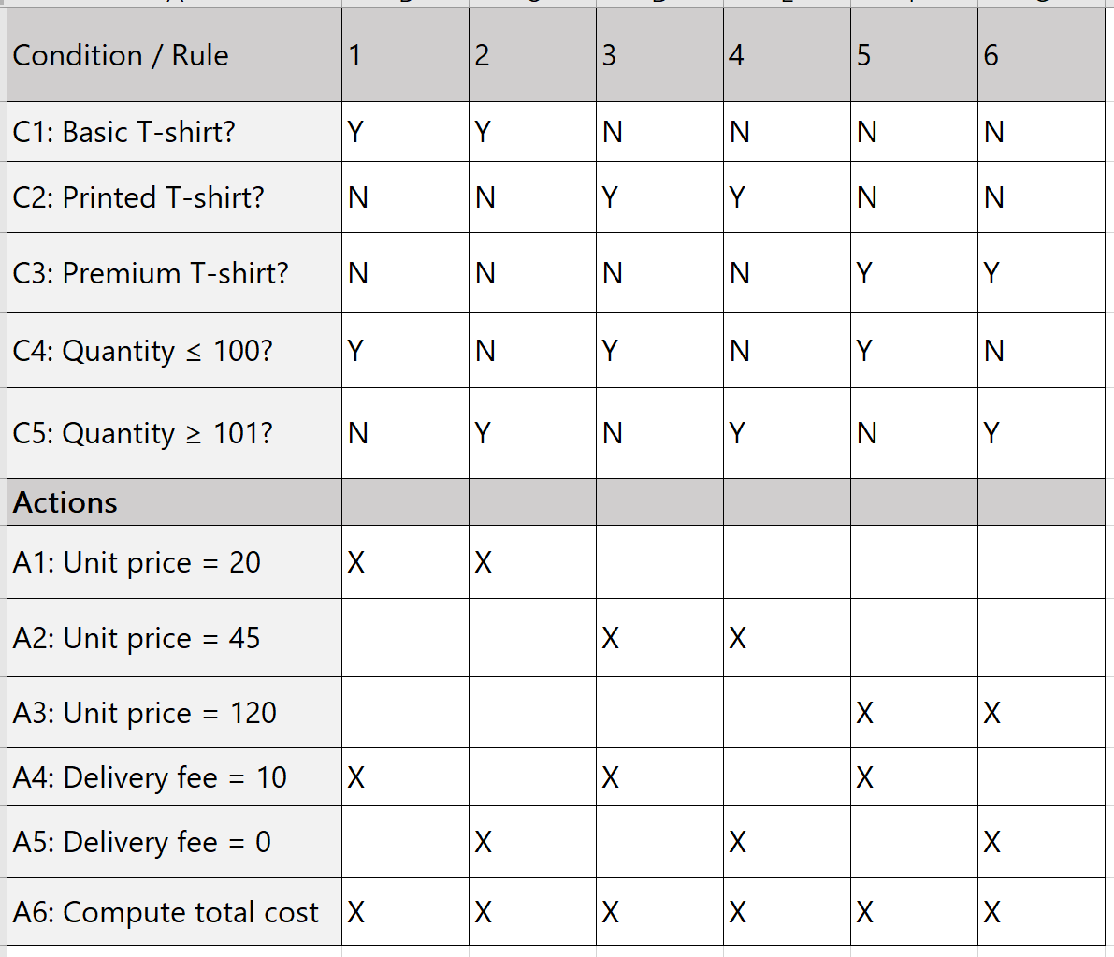
decision table (explicit values)
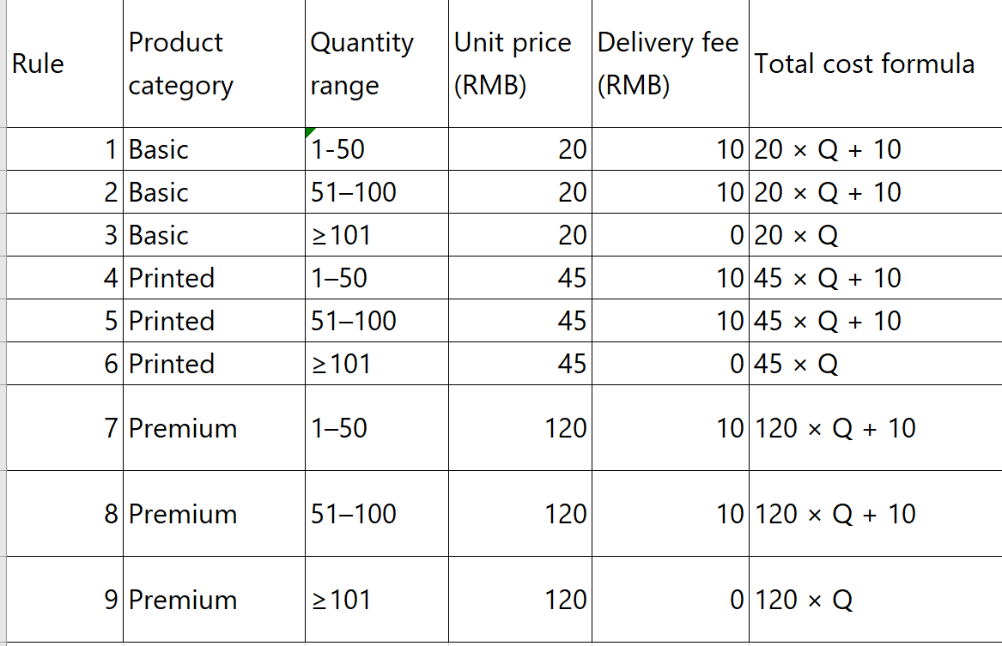
6.2 Normal Boundary Value Testing Cases
Boundary identification:
Small quantity boundaries: 1 (min), 50 (max)
Medium quantity boundaries: 51 (min), 100 (max)
Large quantity boundaries: 101 (min, also the delivery‑fee cutoff) and a typical large value (e.g., 150)

Critical boundary between “with delivery fee” and “no delivery fee”: 100 vs 101

Normal Boundary Value Testing uses only valid boundary values from each equivalence class (no invalid inputs like 0 or negative numbers).

Test cases
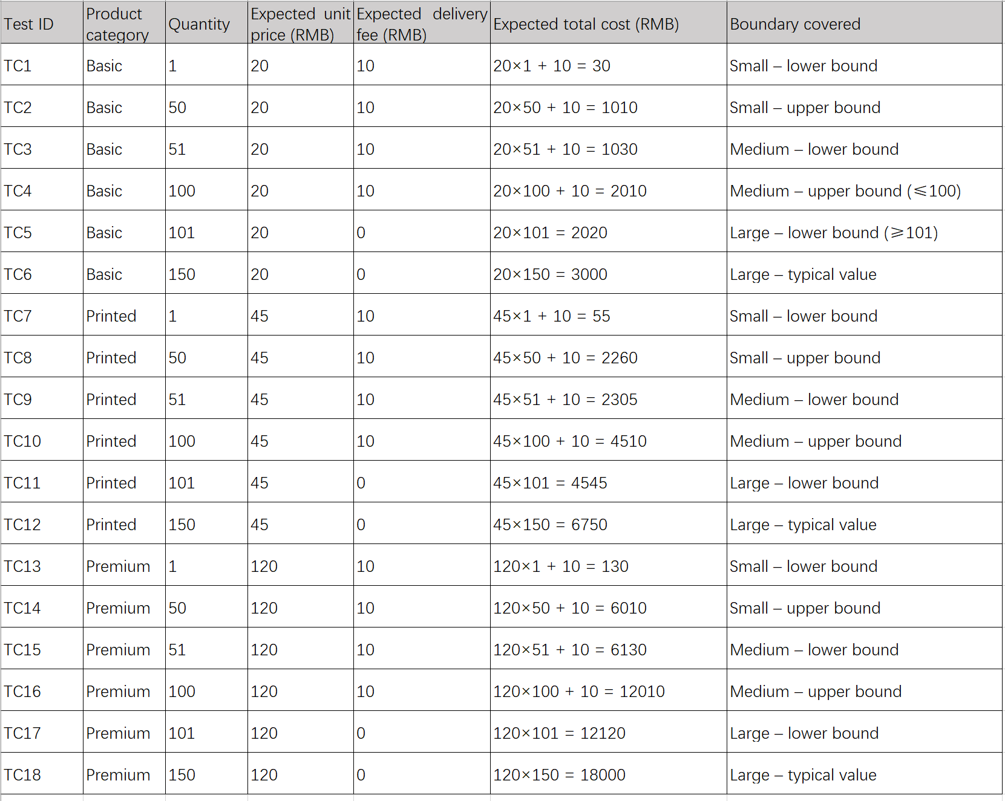
Explanation:

Each product category (Basic, Printed, Premium) is tested with all key boundary values: 1, 50, 51, 100, 101, and a representative large quantity (150).

The critical boundary (100 vs 101) verifies that the delivery fee changes from 10 RMB to 0 RMB correctly.

All inputs are valid (quantity ≥1), making these Normal boundary value test cases.

The test cases fully cover all six rules in the decision table.

Consider the following C function adjustValue(int x, int y, int mode).
int adjustValue(int x, int y, int mode) {
int result = 0;

// First if-else statement
if (x > y) { // (1)
result = result + 10; // (2)
} else {
result = result + 5; // (3)
}

// Second if-else statement (separate)
if (mode == 1) { // (4)
result = result * 2; // (5)
} else if (mode == 2) { // (6)
result = result + 20; // (7)
} else {
result = result - 5; // (8)
}

return result; // (9)
}

Question 1: Draw a control flow graph corresponding to the function above.
Question 2: Derive a minimal set of test cases that can achieve branch coverage (also known as decision coverage) based on the control flow graph above.
Question 3: Derive a minimal l set of test cases that can achieve McCabe’s Basis Path Testing coverage based on the control flow graph above

Number of nodes N=9N=9 (labeled 1 to 9)
Number of edges E=11E=11
Cyclomatic complexity V(G)=E−N+2=11−9+2=4V(G)=E−N+2=11−9+2=4
A set of linearly independent paths (basis set) covering all edges/nodes:

Path ID Description Path (node sequence)
P1 x > y, mode == 1 1 → 2 → 4 → 5 → 9
P2 x > y, mode == 2 1 → 2 → 4 → 6 → 7 → 9
P3 x > y, mode == other (≠1,≠2) 1 → 2 → 4 → 6 → 8 → 9
P4 x ≤ y, mode == 1 1 → 3 → 4 → 5 → 9

